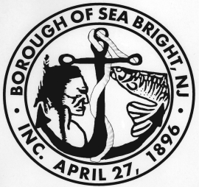
BOROUGH OF SEA BRIGHT
MONMOUTH COUNTY, NEW JERSEY
1099 Ocean Avenue
Sea Bright, New Jersey 07760

PROPERTY TAX / SEWER CERTIFICATION

DATE: December 9, 2022

William A G Inc
1106 Ocean Avenue
Sea Bright, NJ 07760

RE: Block 13 Lot 37

Please be advised taxes are current through 4th quarter 2022. Sewer is current through the 3rd quarter 2022 on the above-mentioned property.

Please feel free to contact me if you have any questions.

PATRICIA M. SPAHR
Tax/Sewer Collector

NOTE* If Planning Board meeting is rescheduled or continued for this property another tax/sewer certification is required.

